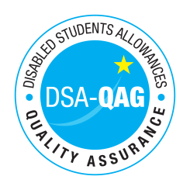
Counselling and Psychological Services - NMH Rates

Period covered - 01/04/2021 through to 30/06/2022

The table below shows NMH rates. The greyed out cells indicate that the NMH provider does not offer these services.

Note: NMH Support Rates shown per hour in the table below.
 | Standard Rate (in-person) |  |  | Distance Learning only (in-person, in-home |  |  | Remote Delivery (e.g. Facetime/Skype or similar) Only
Band 4 Specialist Access and Learning Facilitators
Specialist Mentor – Mental Health | 61.00 | n/a | 61.00

