Car Parking - Equality Impact Assessment Stage 2
The first Equality Impact Assessment (EIA) was conducted at the stage of reviewing the car parking process at the University of Glasgow. This ensured the University had given due consideration to the criteria identified to allocate the permits. This EIA is available at Appendix A.
The second stage of the EIA was to review the allocation of the permits, comparing the pre 2019 and post 2019 allocation by protected characteristic group. This will allow the Car parking Working Group to consider any positive or negative impacts from and equality perspective.
The data included below considers the allocation under both systems, and the protected characteristics of those individuals, as provided in the Core HR system.
This EIA considered data relating to Religion and Belief and to Sexual orientation, however the data showed little or no impact based on the changes to the car parking permit system.
In addition, the Car parking Working Group requested the EIA consider data relating to grade, and those who have responsibility for dependents. This is presented in section five and six.

Age Range
Chart 1 and 2 show the age range of permit holders in the pre and post 2019 system.

Chart 1
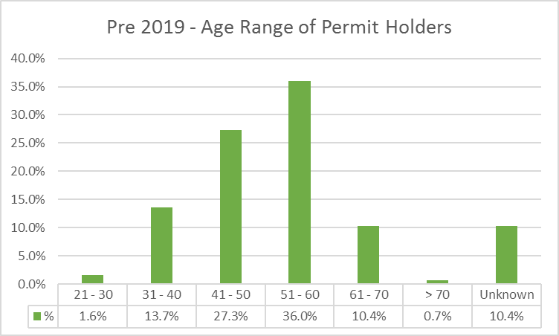
Chart 2
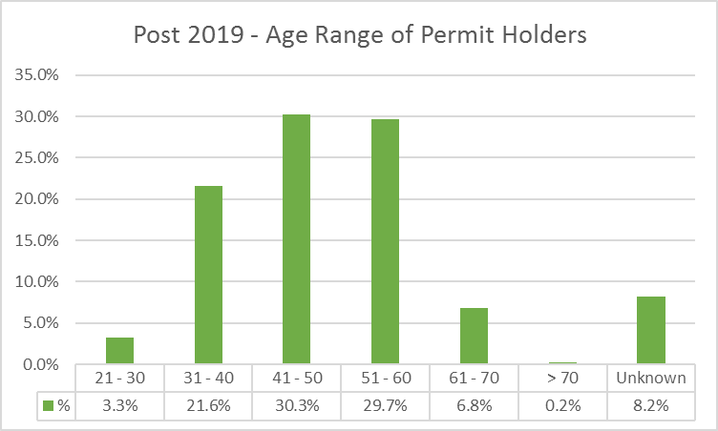
Staff under the age of 40 where more likely to receive a permit in the Post 2019 system, than in the previous system. In the Post 2019 system, the majority of permit holders are in the age range 41-50 with 30.3%, followed by age range 51-60 29.7%.

Disability
Chart 3 and 4 show the Disability status of permit holders in the pre and post 2019 system. Disability data is presented as a binary yes/no response.

Chart 3
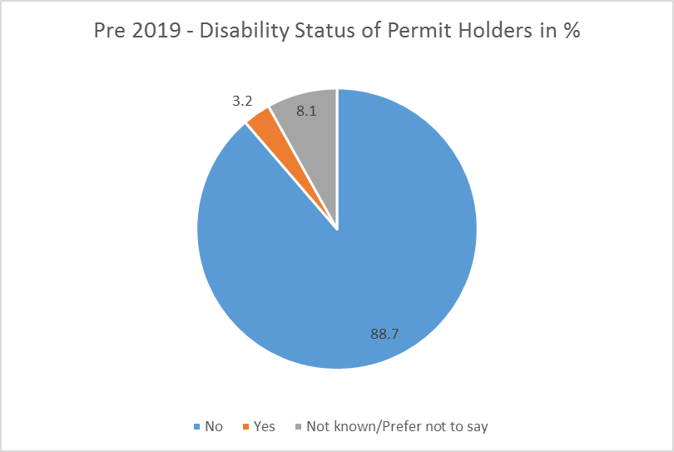
Chart 4
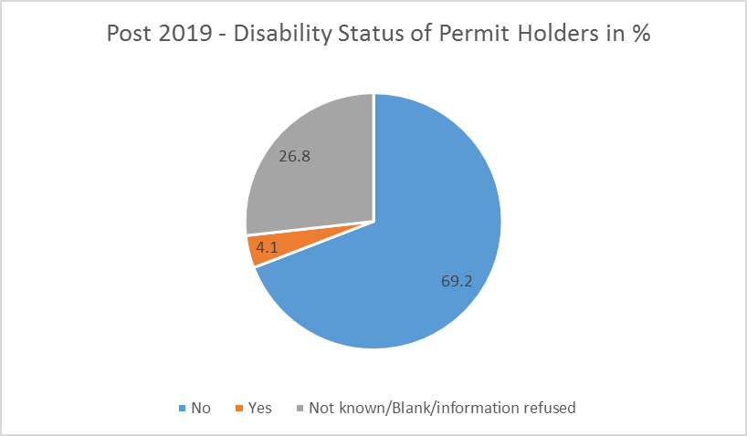
Chart 3 and 4 shows there has been a 0.9% increase in Disabled staff becoming permit holders. It should be noted that under both schemes, Blue Badge holders automatically receive a permit. There has been a significant increase in the percentage of staff who have not disclosed their disability status, increasing by 18.7%.

Ethnicity
Chart 5 and 6 show the Ethnicity of permit holders in the pre and post 2019 system. Ethnicity data has been presented as White and Black, Asian and Minority Ethnic (BAME).

Chart 5
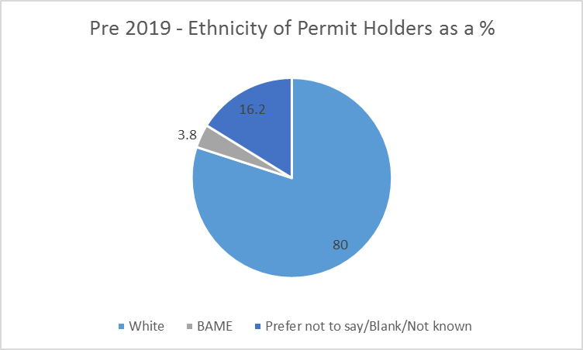
Chart 6
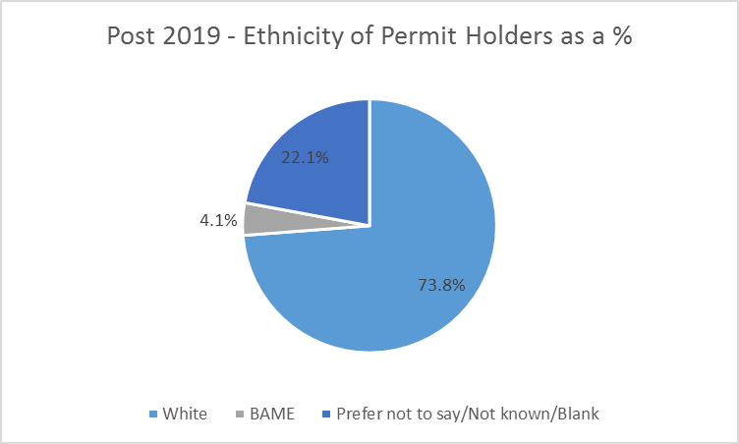
Chart 5 and 6 show there has been an increase in BAME permit holders under the post 2019 system. It should be noted there has been a 6% increase in permit holders stating Prefer not to say/Blank/Not know.

Sex
Chart 7 and 8 show the Sex of permit holders in the pre and post 2019 system.

Chart 7
Pre 2019 Sex of Permit Holders as a %
41
59
Female Male
Chart 8
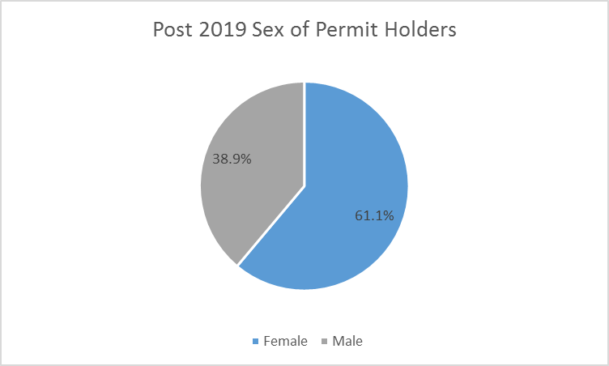
Chart 7 and 8 show a variance in the sex of permit holders, change by 2.1% in favour of women.

Dependents
Chart 9 and 10 show the Dependent status of permit holders in the pre and post 2019 system. The post 2019 took into account permit applicants caring responsibilities for the first time.

Chart 9
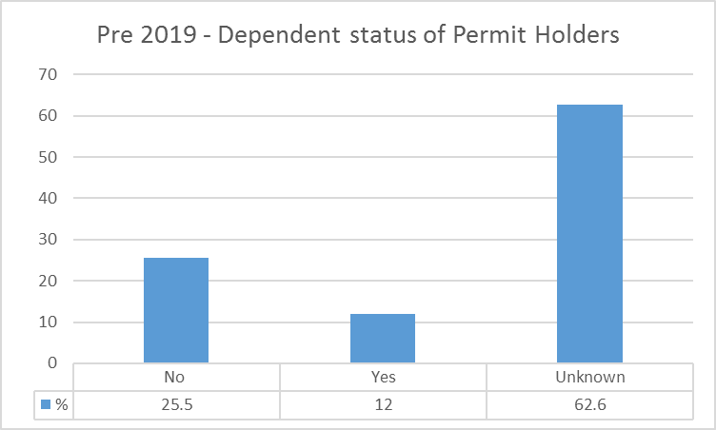
Chart 10
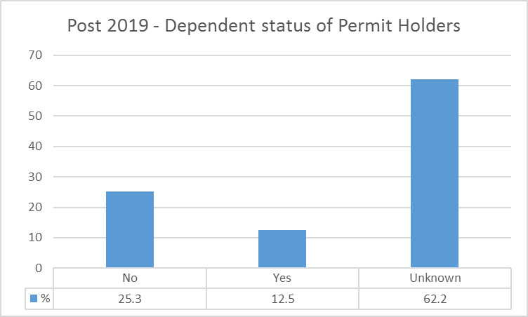
Charts 9 and 10 show little variance in the percentage of permit holders with dependents (0.5%). It should be noted over 60% of permit holders have not informed the University if they have dependents or not.

Grade
Chart 11 and 12 show the grades of permit holders in the pre and post 2019 system.

Chart 11
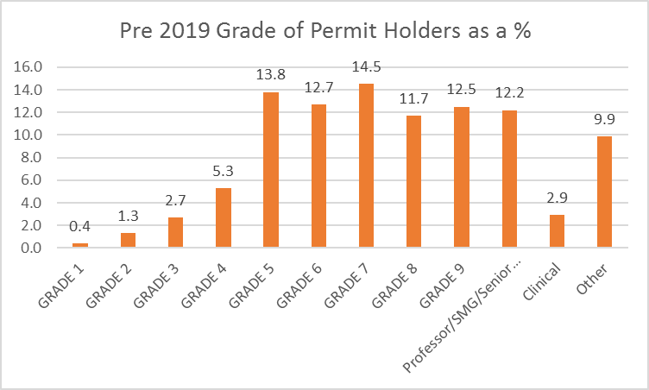
Chart 12
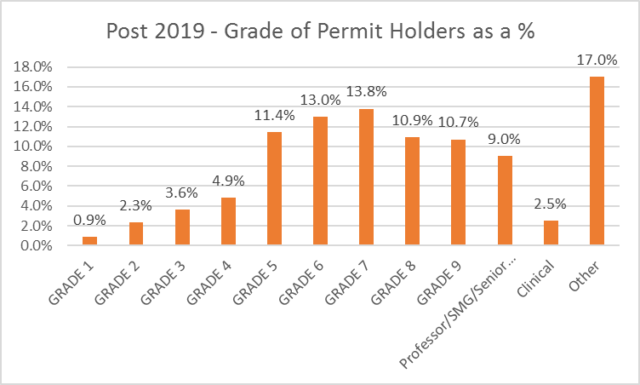
In Charts 11 and 12 the cluster of Grades 5-7 showing the largest percentage of permit holders in both pre and post systems. There are fewer permit holders in Grade 8-9 in the Post 2019 system, and this drops by over 3% for Professors/SMG/Senior Administrators in the Post-2019 system. There has been a sharp increase in the
percentage of ‘Other’, this includes Beatson staff, students and other affiliated individuals.

Conclusion
To conclude, there have been changes for individuals in receipt of a car parking permit when comparing the pre and post 2019 system. In general younger staff, disabled staff, BAME staff and women are more likely to receive a permit in the post 2019 system.
It was thought this would have a significant impact on parents and carers, however the data has not shown this. In addition, staff at senior grades are less likely to receive a permit in the post 2019 system than the pre 2019 system.
This data analysis need to be caveated with the significant data gaps, as with the exception of age and sex, many staff have not completed their Diversity data on Core, and therefore the University does not hold this information. In addition, a significant percentage of permit holders are not employees – they are either students, affiliates of the University, or employees of other organisations (such as the Beatson) – and as this is personal, sensitive data this is not held.
The data analysis does not present other issues which have arisen relating to protected characteristics and car parking permits, namely:
  - Whether the criteria should be altered to allow disabilities to be taken into account, where an individual does not qualify for a Blue Badge.
  - Where they payment process should be provided on a pro-rata basis for those who work less than 1FTE.
These issues will be given due consideration by the Car Parking Working Group when the system is reviewed.

Mhairi Taylor
Equality and Diversity Unit March 2019

